Your Parish Episcopal Church
Your Town, PA
The __ Sunday in/after __________

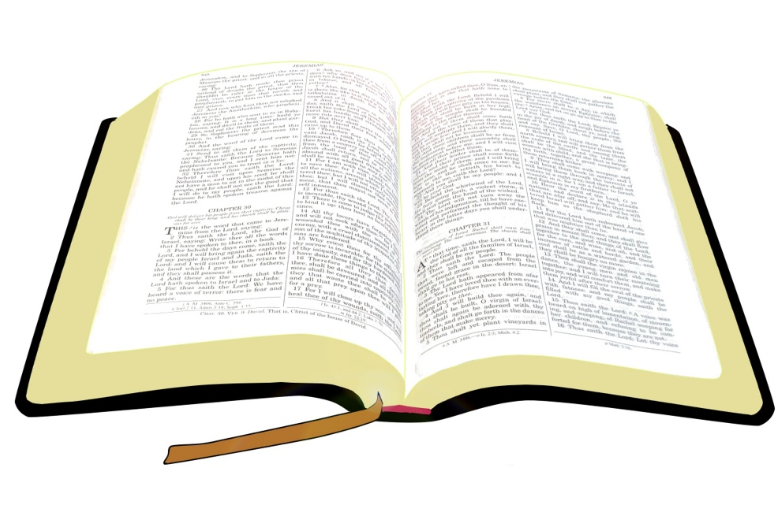

Name of Worship Leader, Officiant

[Parish Address]
[Parish Phone Number]
[Parish Email, Website, Social Media]

The Liturgy of the Word: Rite Two
Adapted from The Holy Eucharist: Rite Two
in the Book of Common Prayer

The Entrance Rite
Opening Hymn: Title Hymnal 000
Opening Acclamation: BCP 351
Blessed be God: Father, Son, and Holy Spirit.
And blessed be his kingdom, now and forever. Amen.
Opening Sentence: BCP 351-352

Confession of Sin BCP 352-353
Gloria / Kyrie / Trisagion BCP 356 / Hymnal S000
Collect of the Day Insert

The Lessons Insert
Please remain seated for the Gospel reading. The Gospel will be announced, and should be responded to, in the same manner as the other lessons:
The Word of the Lord.
Thanks be to God.

The Sermon Name of Preacher
The Nicene Creed BCP 358-359
The Prayers of the People, Form III BCP 387

The Offertory
Offertory Hymn: Title Hymnal 000

The Lord’s Prayer BCP 364

The Closing Rite
The Grace:
The grace of our Lord Jesus Christ, and the love of God, and the fellowship of the Holy Spirit, be with us all evermore. Amen.
Closing Hymn: Title Hymnal 000

Announcements

Include announcements, calendar items, and prayer lists, and other information here.

