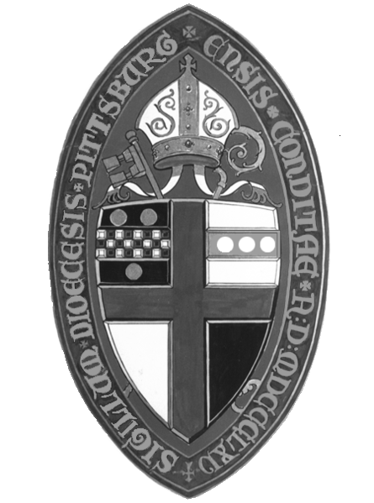2023 Audit Committee
or CPA Qualifications Form

This form is to be completed & submitted to the diocesan office by April 15, 2024

Date

Parish

Address

For person completing this form, include the following contact information:

Name: |  |  | Title:
Phone Number: |  |  | E-mail Address:

Parish has contracted the services of the following independent certified public accounting firm:

Name of firm:
(Please enclose a copy of the engagement letter.)
OR

Parish has convened an Audit Committee comprised of the following individuals:

Name:
Qualifications/Audit Training or Experience:
Name:
Qualifications/Audit Training or Experience:
Name:
Qualifications/Audit Training or Experience:
Name:
Qualifications/Audit Training or Experience:

