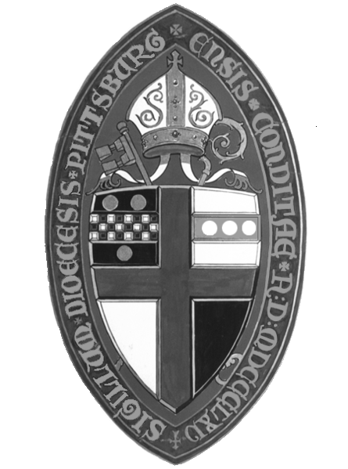2023 Audit Committee Certificate

This form is to be completed by the parish Audit Committee
and submitted as part of the completed audit package.

Date

Parish

Address

We have inspected the accompanying statement of financial position (balance sheet) as of December 31, 2023 (audit year), and the related statement of activities (income statement) for the year then ended December 31, 2023. Our inspection was made in accordance with the audit guidelines of the Episcopal Church as outlined in Chapter VI of the Manual of Business Methods in Church Affairs and the Parish Audit by Committee Manual published by the diocese. The financial statements are prepared on a (check one) cash basis, modified accrual basis, or accrual basis in accordance with principles adopted by the Episcopal Church and approved by its General Convention except as noted. Note exceptions here, if any:

We have taken steps to see that the accompanying financial statements present fairly, in all material respects, the financial position of the Congregation on December 31, 2023; and that the changes in its net assets and its cash flows for the year then ended are in accordance with the principles authorized by General Convention of the Episcopal Church on a basis consistent with that of the preceding year.

Our inspection and certificate are not meant to be construed as an audit and opinion rendered by a Certified Public Accountant.

Members of the Audit Committee:

Name |  | Signature
Name |  | Signature
Name |  | Signature
Name |  | Signature

